Acc jurnal.docx
by arieanh23@gmail.com 1

Submission date: 03-Jul-2024 02:41PM (UTC+0530)
Submission ID: 2411998092
File name: Acc_jurnal.docx (42.99K)
Word count: 2313
Character count: 16330

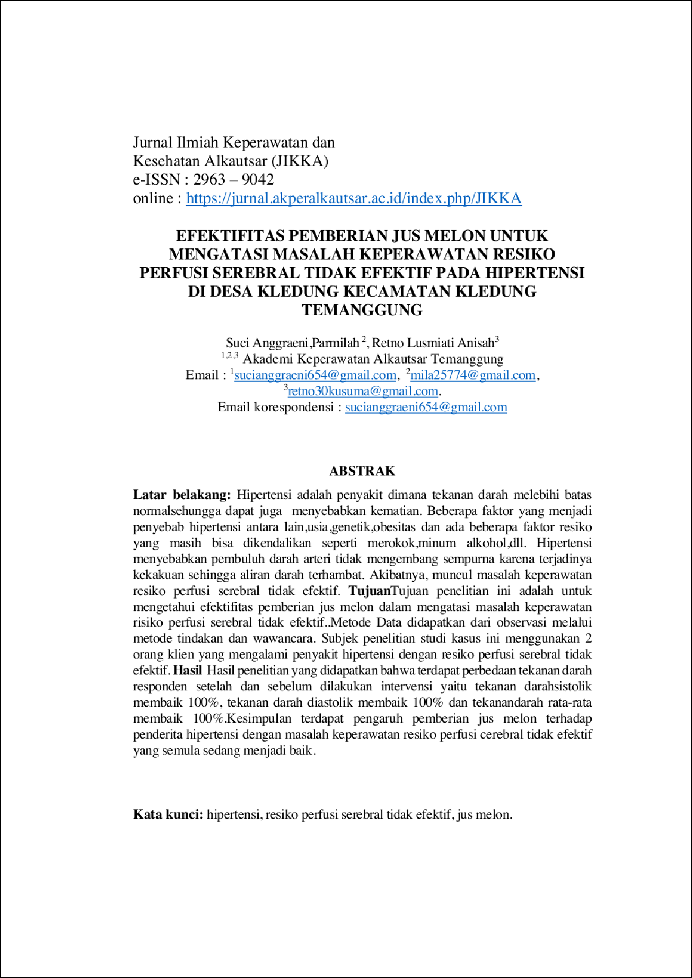

3

2

10

9
2

5

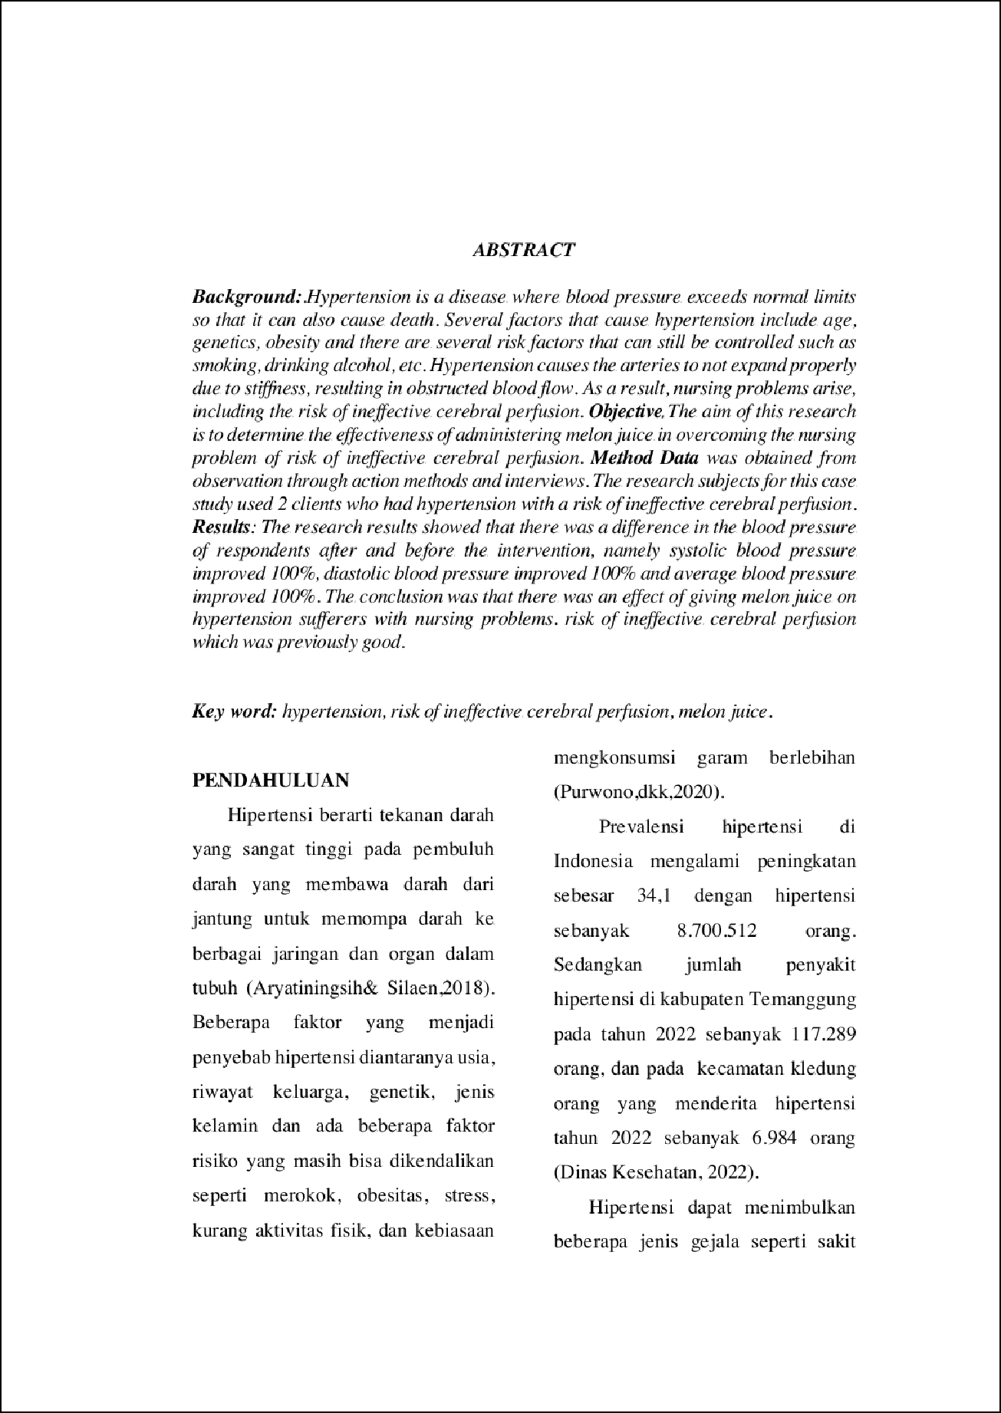

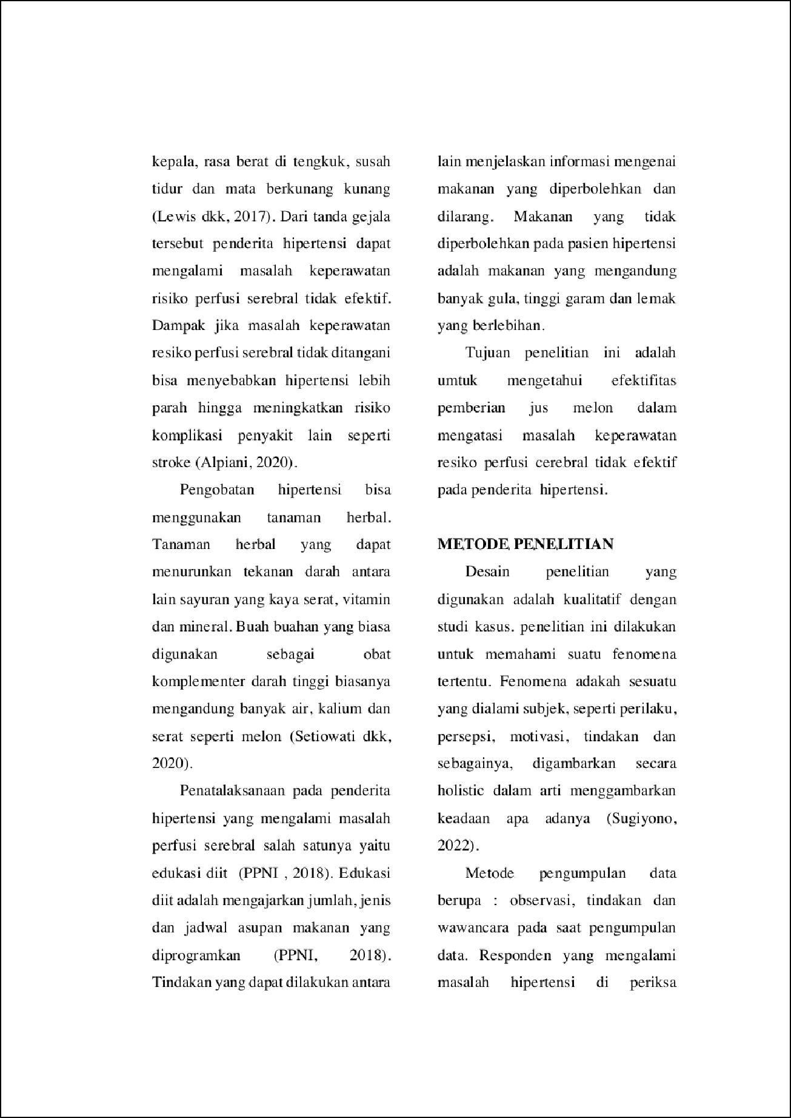

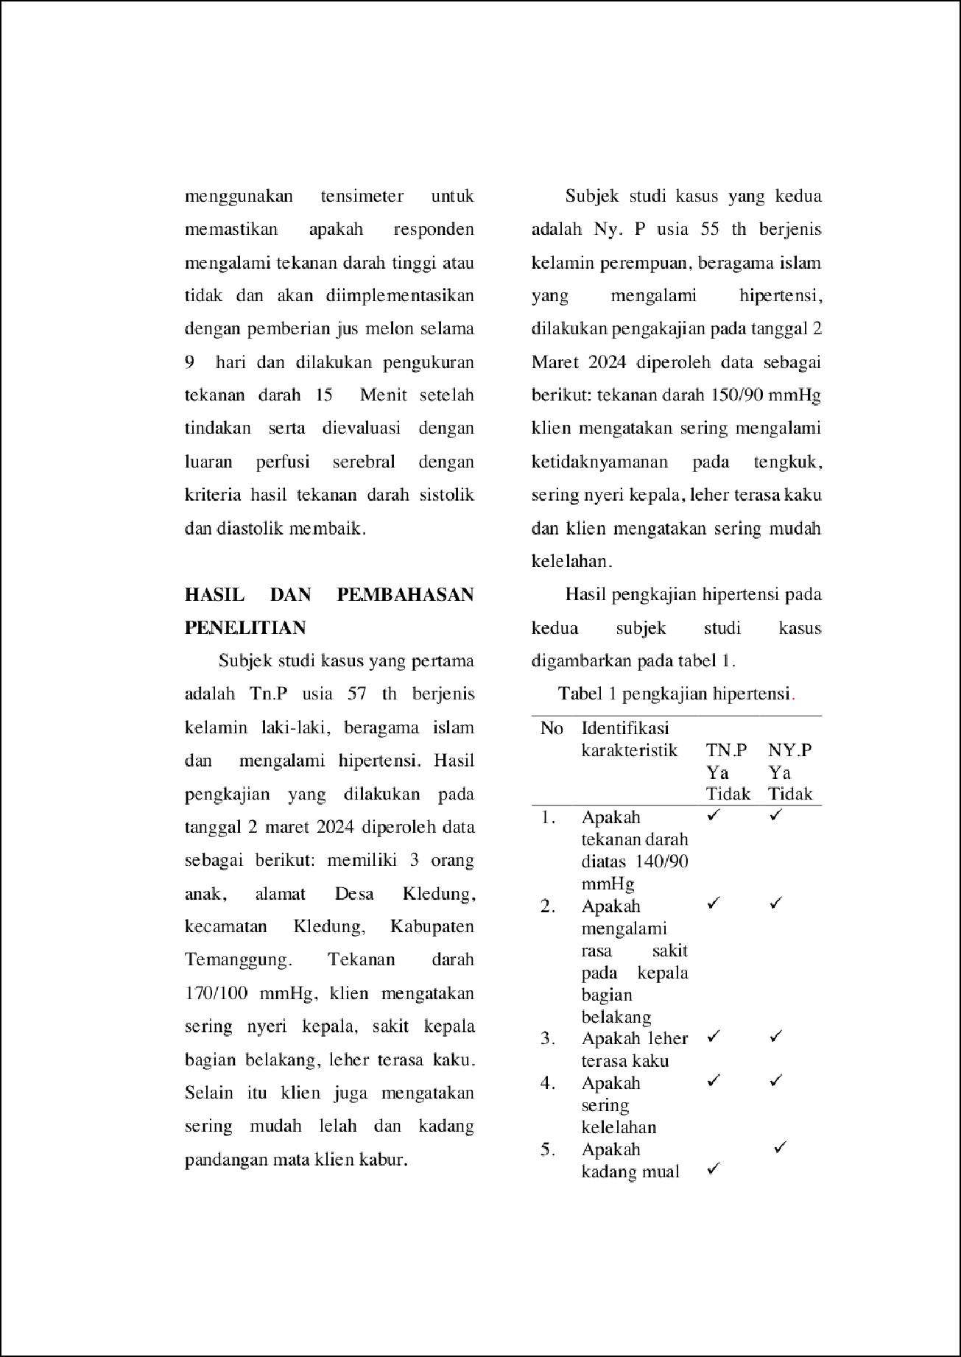

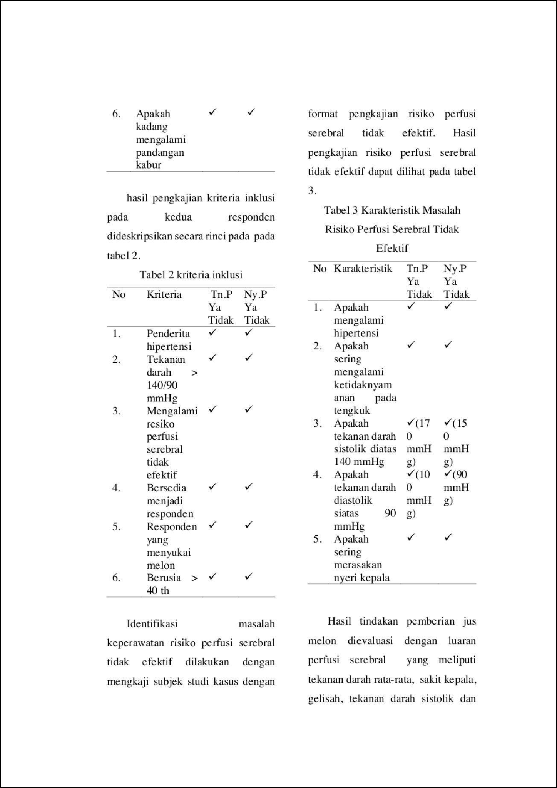

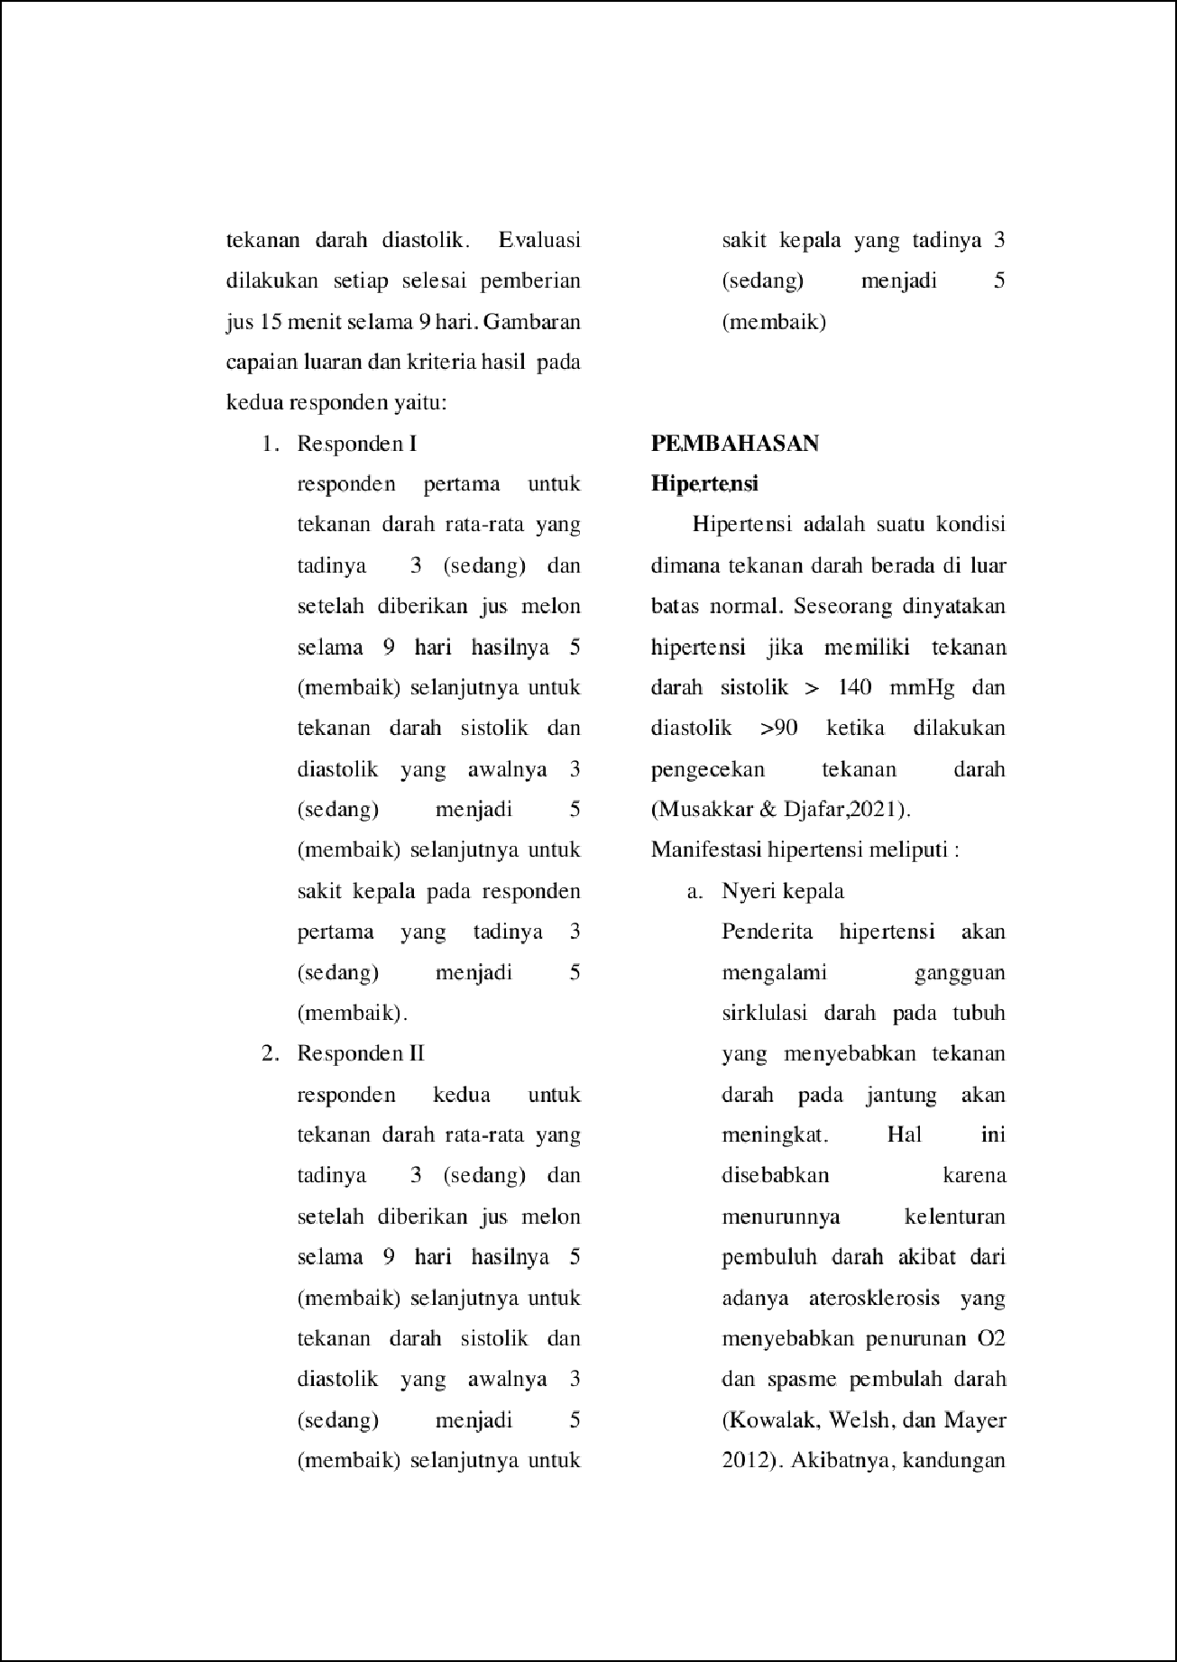

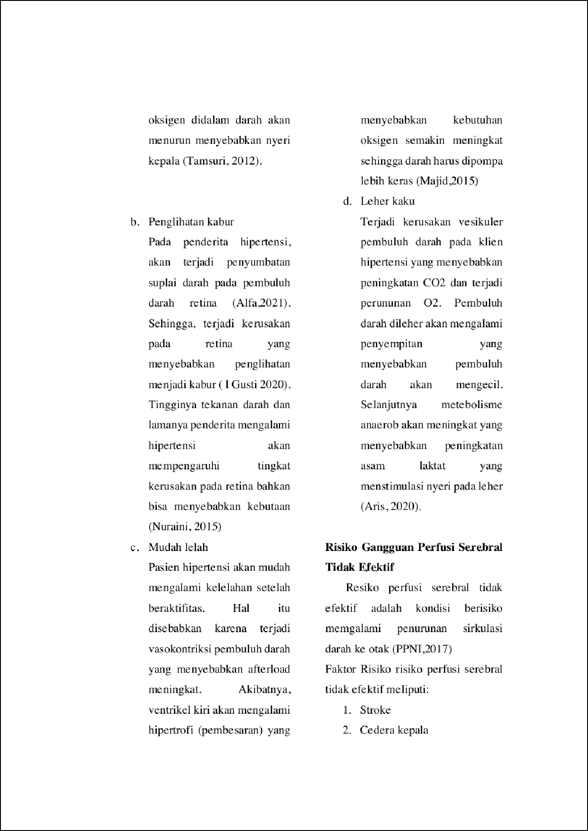

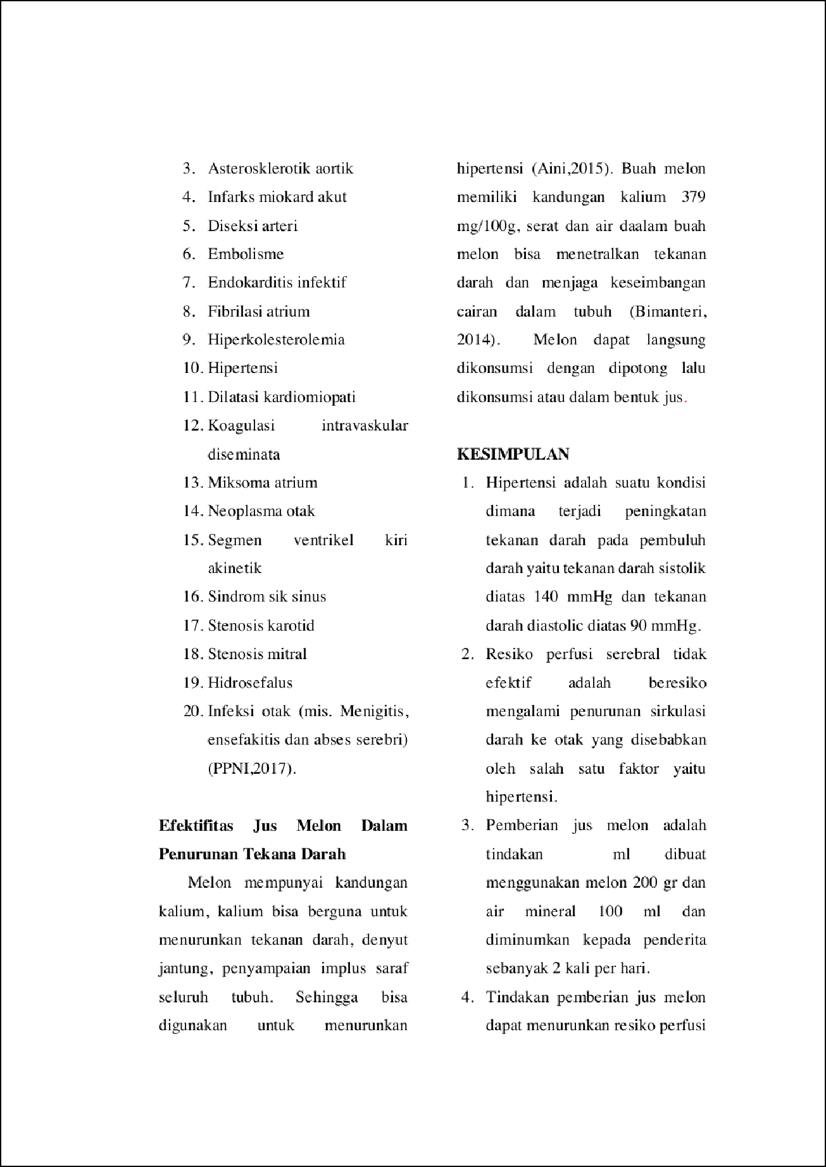

1

7

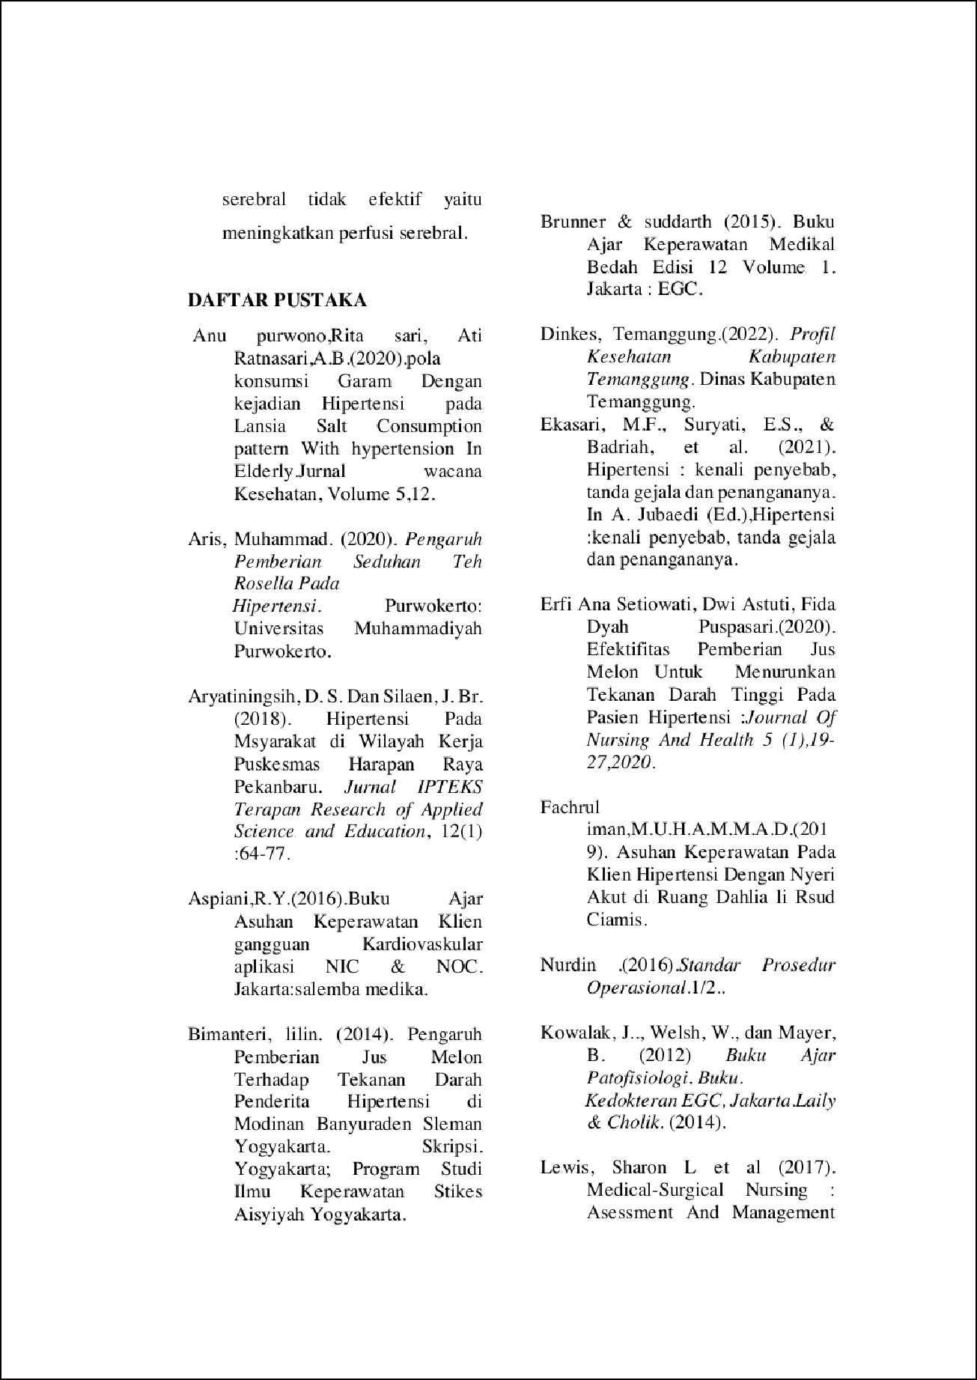

2

6

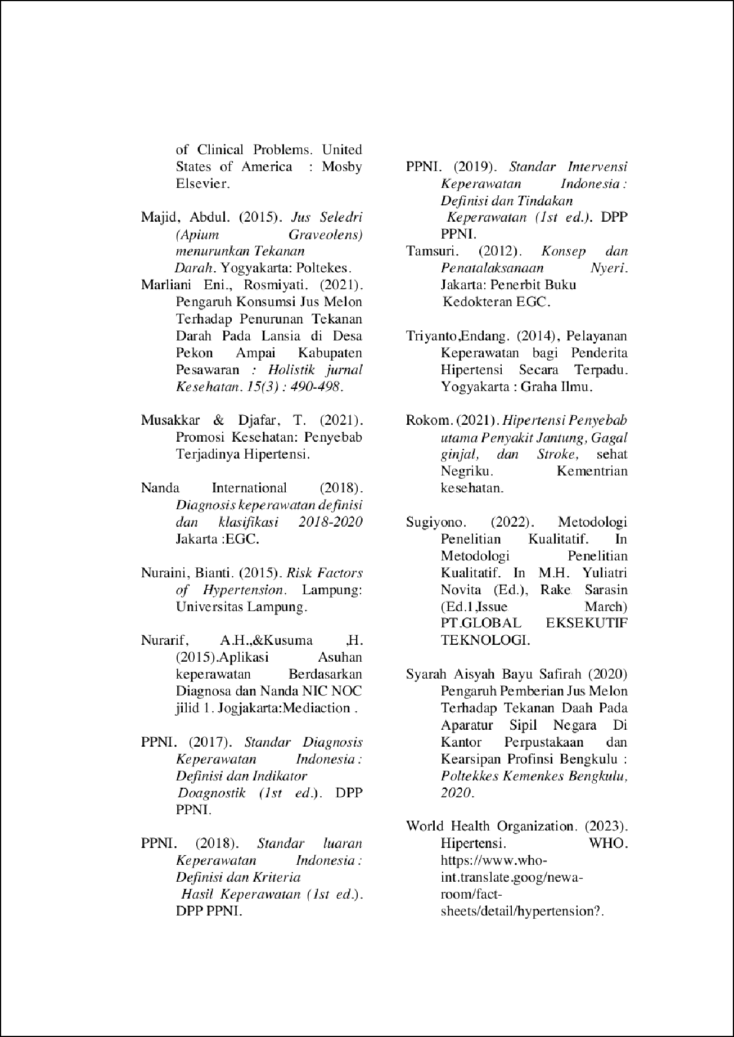

12

4

11

8



Acc jurnal.docx
ORIGINALITY REPORT
7

%
SIMILARITY INDEX

4%
INTERNET SOURCES

3%
PUBLICATIONS

2%
STUDENT PAPERS

PRIMARY SOURCES

Submitted to Poltekkes Kemenkes Sorong
1
Student Paper

repository.unimugo.ac.id
2
Internet Source

repository.poltekkesbengkulu.ac.id
3
Internet Source

samoke2012.wordpress.com
4
Internet Source

123dok.com
5
Internet Source

6 Rahmania Ambarika, Samrina. "The Eﬀect Of Health Education On Knowledge In The Prevention Of Congestive Heart Failure For At-Risk Groups", Journal of Global Research in Public Health, 2023
Publication

repository.ub.ac.id
7
Internet Source
1%
1%
1%
1%
<1%
<1%

<1%

8

9

10

11

12
Sarinah Sri Wulan, Dimas Ning Pangesti, Sri Suharti, Rahmawati Dian Nurani, Ida Yatun Khomsah. "Pengaruh rebusan daun kelor (moringa oliﬁera) terhadap tekanan darah pada penderita hipertensi", JOURNAL OF Mental Health Concerns, 2023
Publication

garuda.kemdikbud.go.id
Internet Source

www.bukumedis.com
Internet Source

Diva Dewi Sarina, Susanti Widiastuti. "Analisis Asuhan Keperawatan melalui Intervensi Clapping dan Postural Drainage dengan Masalah Bersihan Jalan Napas Tidak Efektif dengan Diagnosa Bronchopneumonia", Jurnal Kreativitas Pengabdian Kepada Masyarakat (PKM), 2023
Publication

Jubaedah Jubaedah, Ayu Pratiwi. "Kemampuan Koping Dengan Tingkat Kecemasan Klien Hipertensi", Adi Husada Nursing Journal, 2022
Publication
<1%

<1%
<1%
<1%

<1%

Exclude quotes Oﬀ Exclude matches Oﬀ

Exclude bibliography Oﬀ
Acc jurnal.docx
PAGE 1

PAGE 2
PAGE 3

PAGE 4
PAGE 5

PAGE 6
PAGE 7

PAGE 8
PAGE 9

PAGE 10
PAGE 11

