artikel aghis 3 juni.
by TURNITIN NO REPOSYTORY

Submission date: 04-Jul-2024 06:22AM (UTC-0500)
Submission ID: 2412453382
File name: artikel_aghis_3_juni.docx (34.93K)
Word count: 1904
Character count: 11132

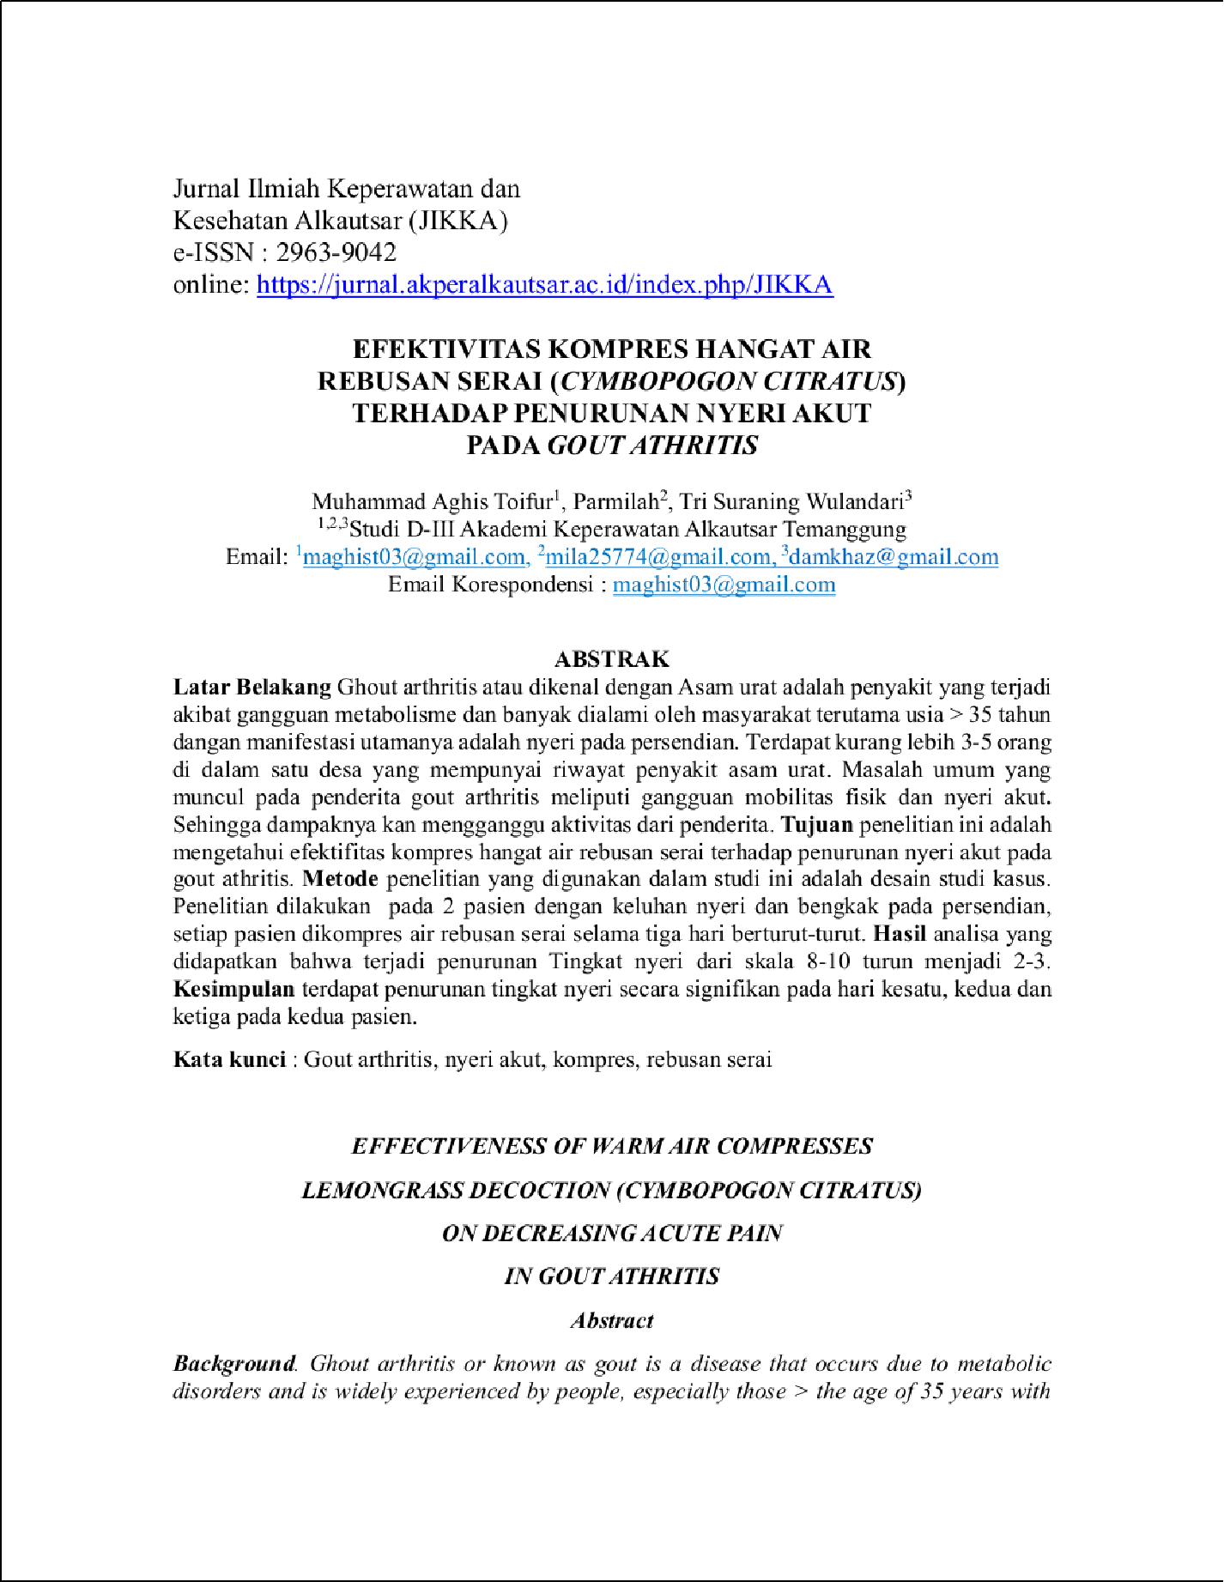

4

1

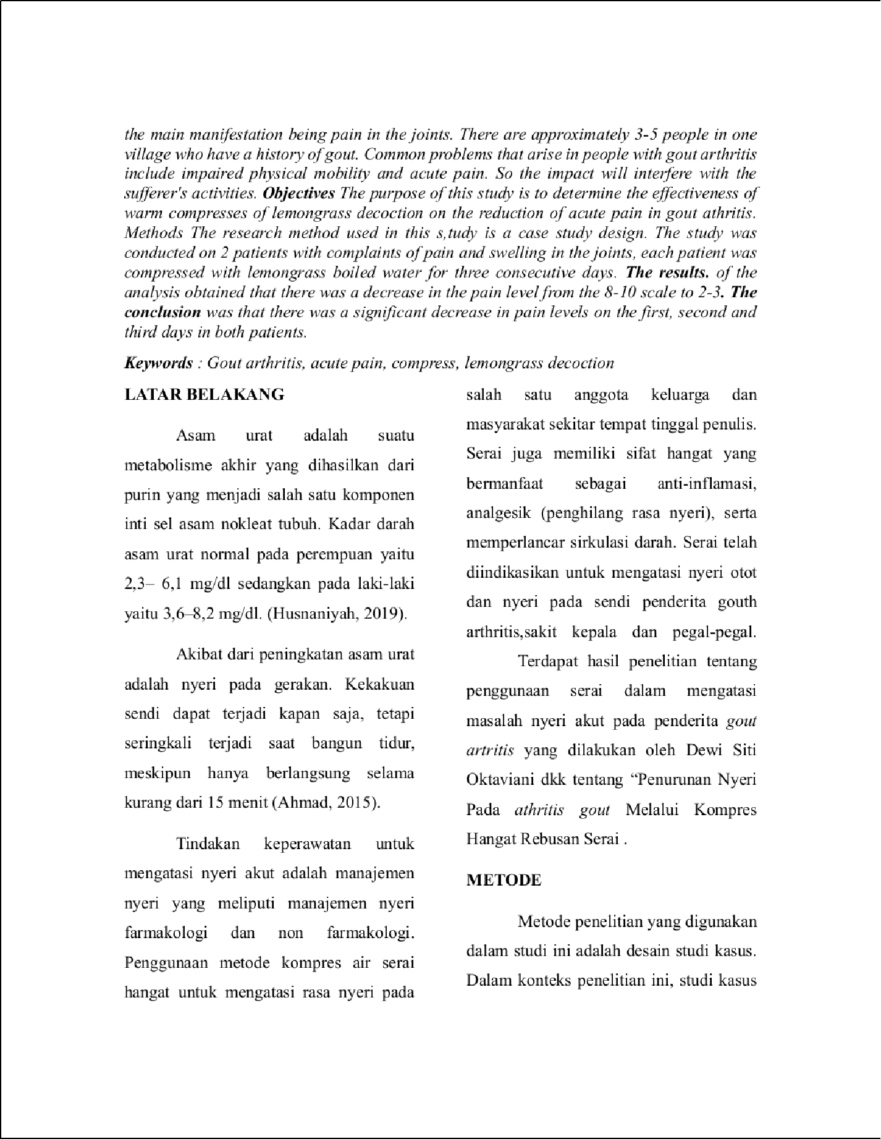

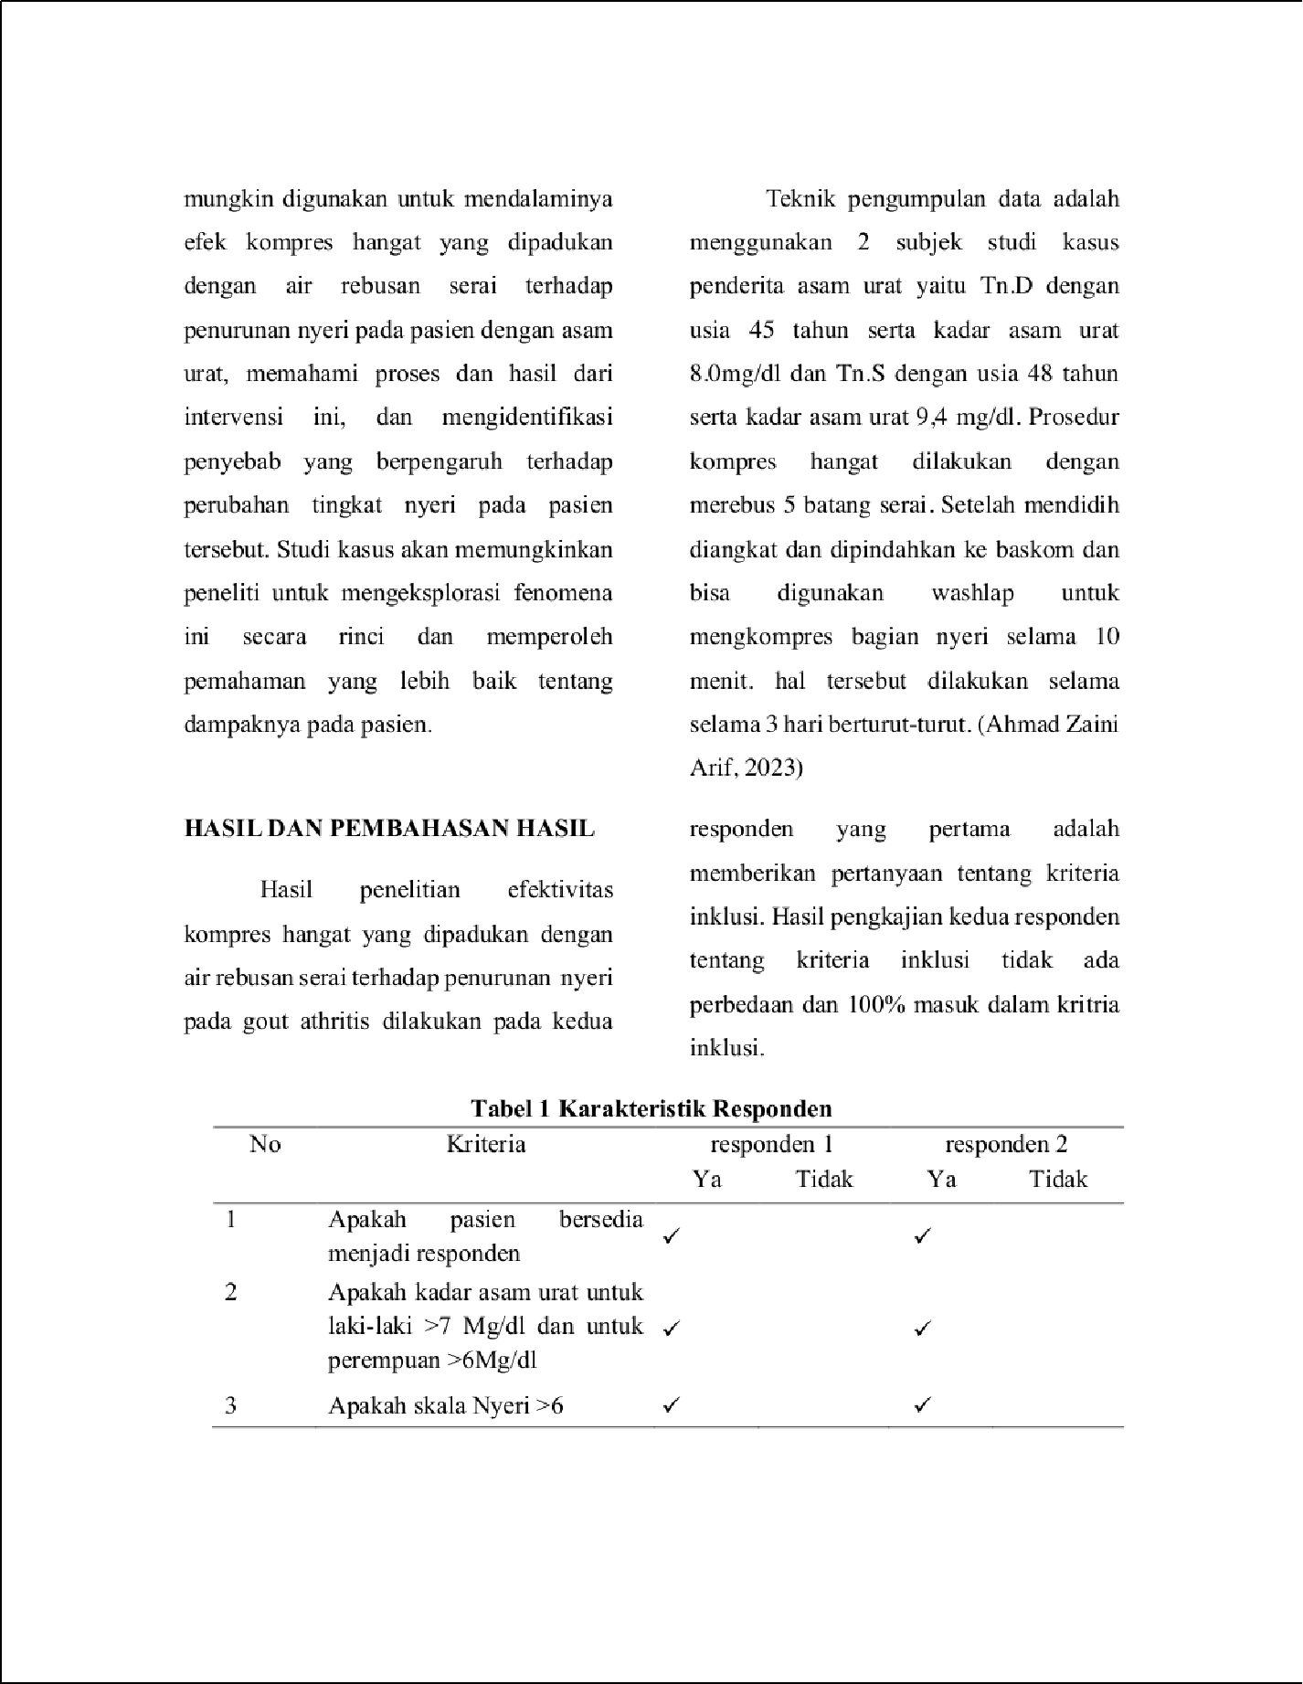

4

1

6

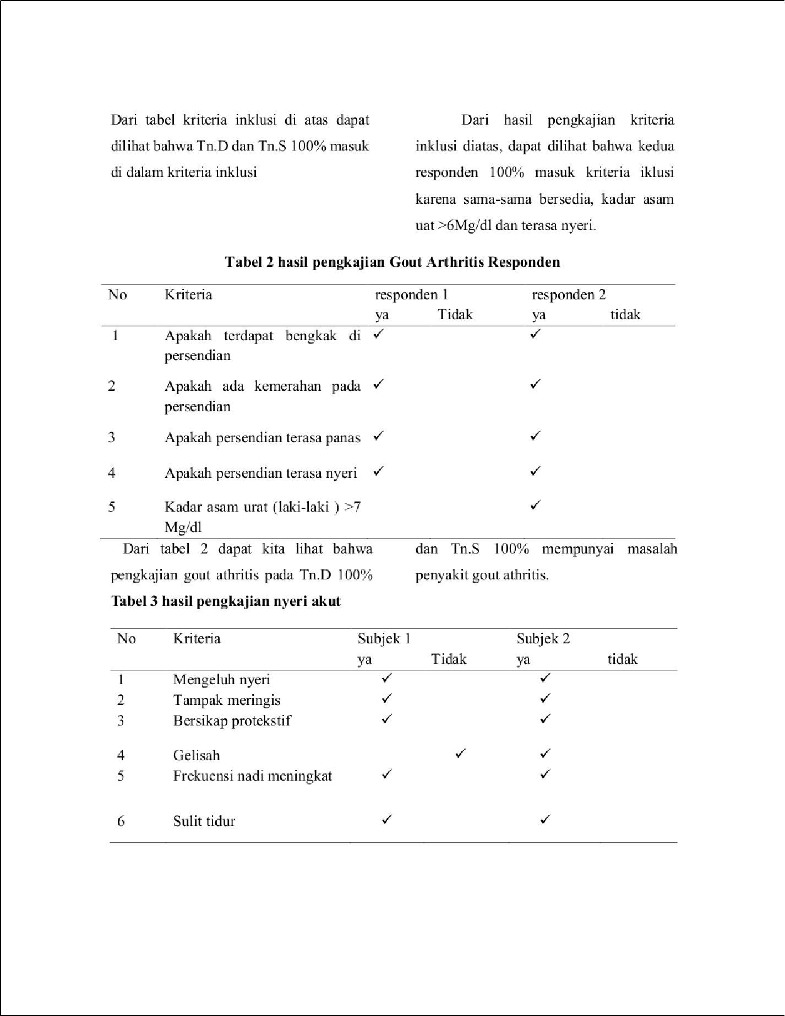

6

7

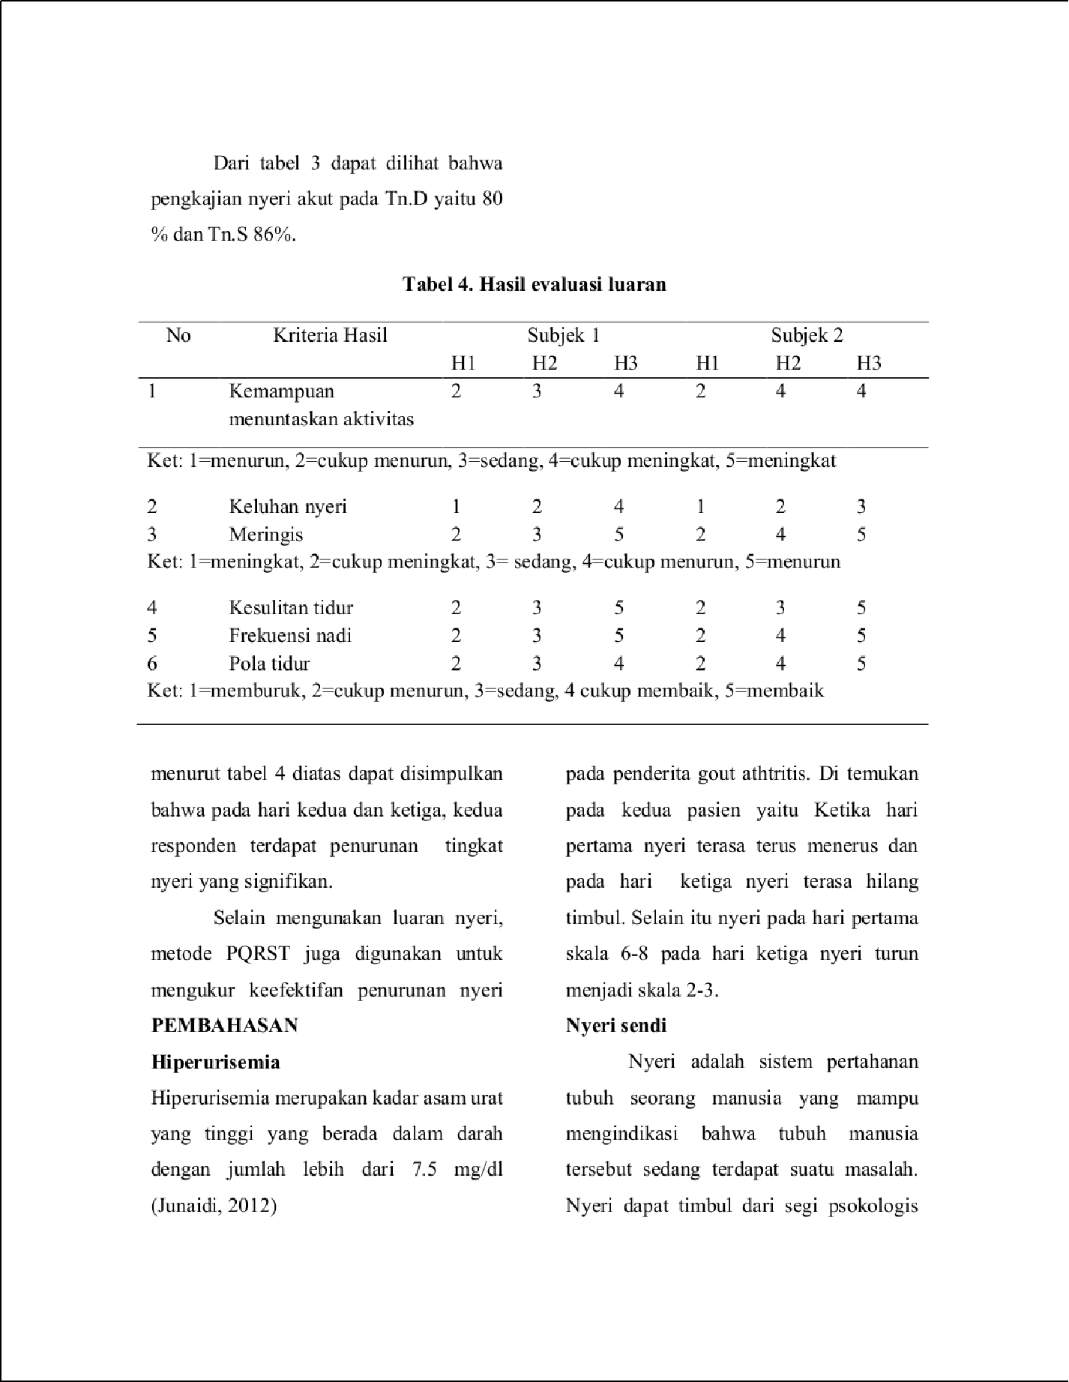

3

3

1

1

2

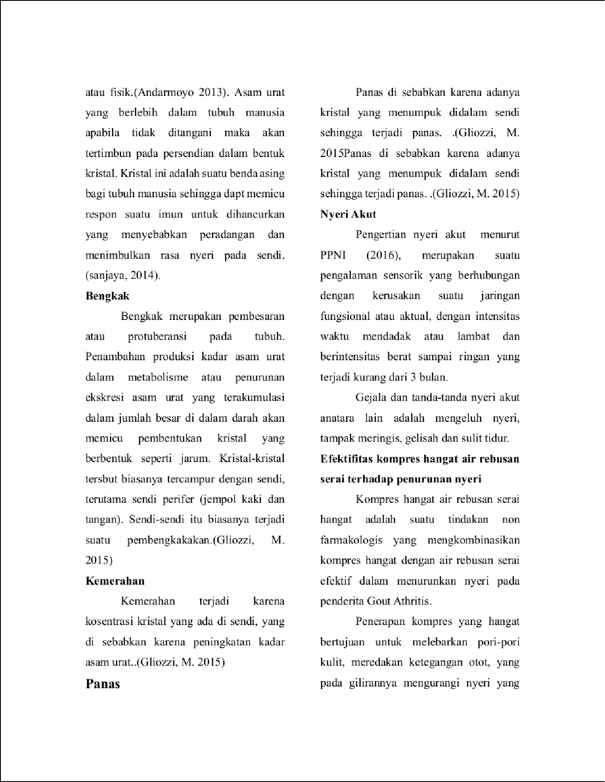

1

5

2

1

1

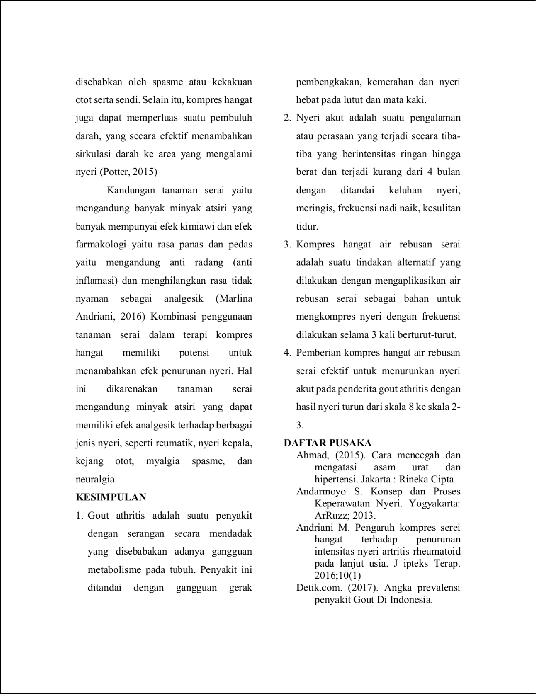

5

1

1

1

2

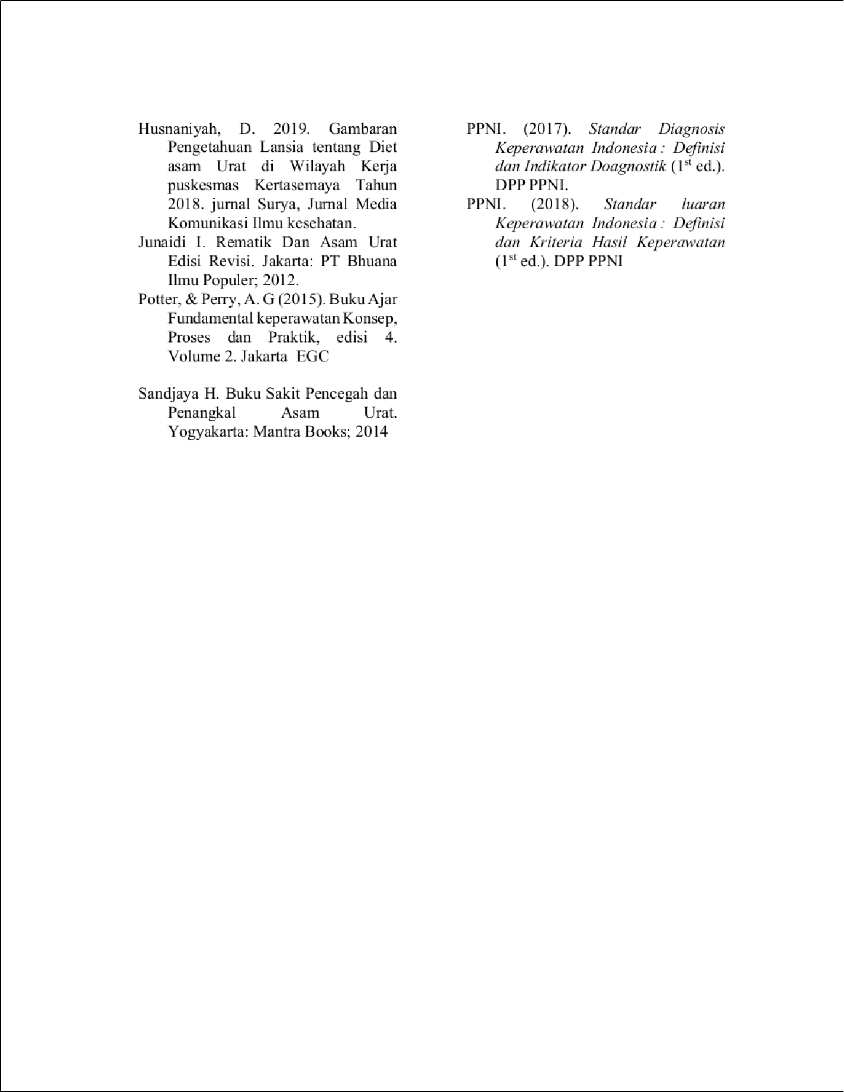

1

1

artikel aghis 3 juni.
18
ORIGINALITY REPORT

%

SIMILARITY INDEX
18%

INTERNET SOURCES
7%

PUBLICATIONS
5%

STUDENT PAPERS

PRIMARY SOURCES

jurnal.poltekkespalu.ac.id
Internet Source %
1
9
3

journal.universitaspahlawan.ac.id
Internet Source %
2
2

repository.unimugo.ac.id
Internet Source %
3
2

repository.poltekkesbengkulu.ac.id
Internet Source %
4
1

repository.poltekkes-kaltim.ac.id
Internet Source %
5
1

docplayer.info
Internet Source %
6
1

repository.poltekkes-denpasar.ac.id
Internet Source %
7

Exclude quotes On Exclude bibliography On
Exclude matches < 20 words

artikel aghis 3 juni.
PAGE 1

PAGE 2

PAGE 3

PAGE 4

PAGE 5

PAGE 6

PAGE 7

PAGE 8

