jurnalirmaa
byCekTurnitin

Submissiondate:21-Jul-202512:44AM(UTC-0400)
SubmissionID:2718280073
Filename:jurnal_irmaa.docx(46.35K)
Wordcount:2608
Charactercount:15262

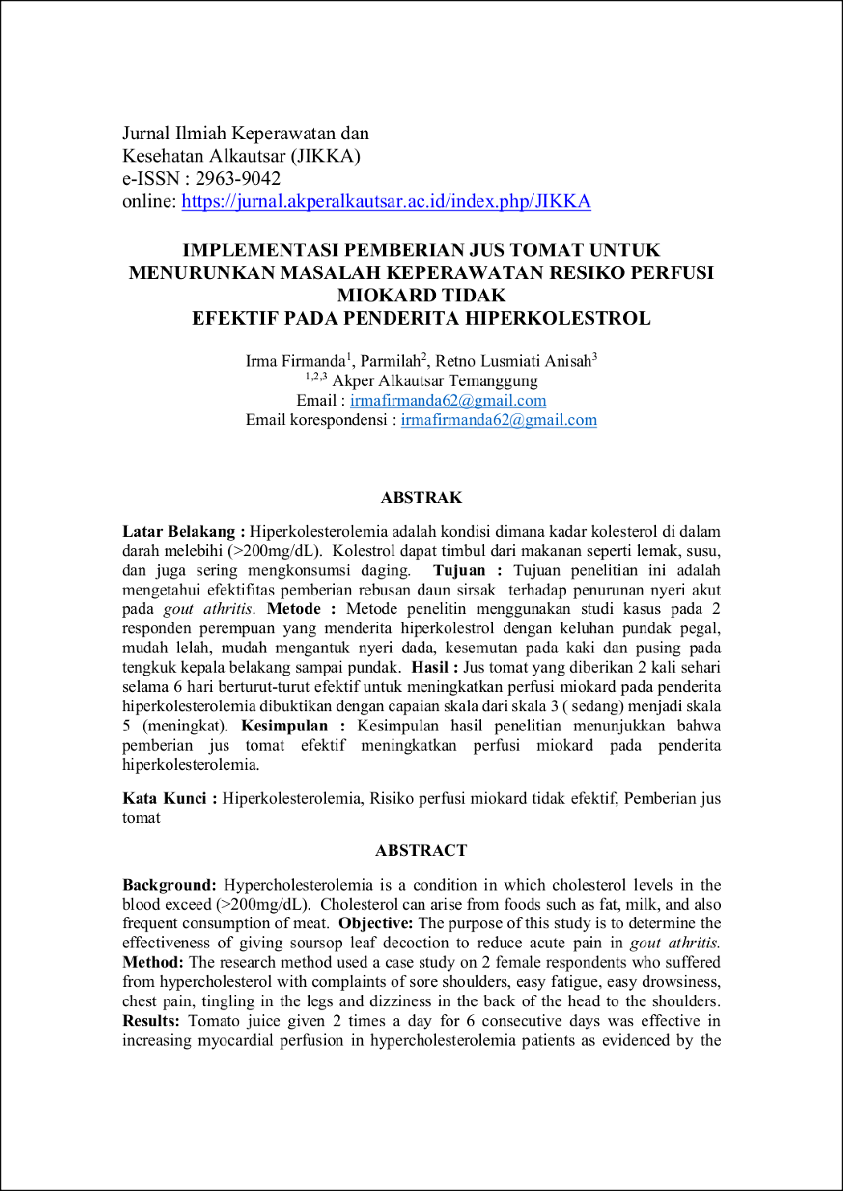
14
13
11
17
5
11

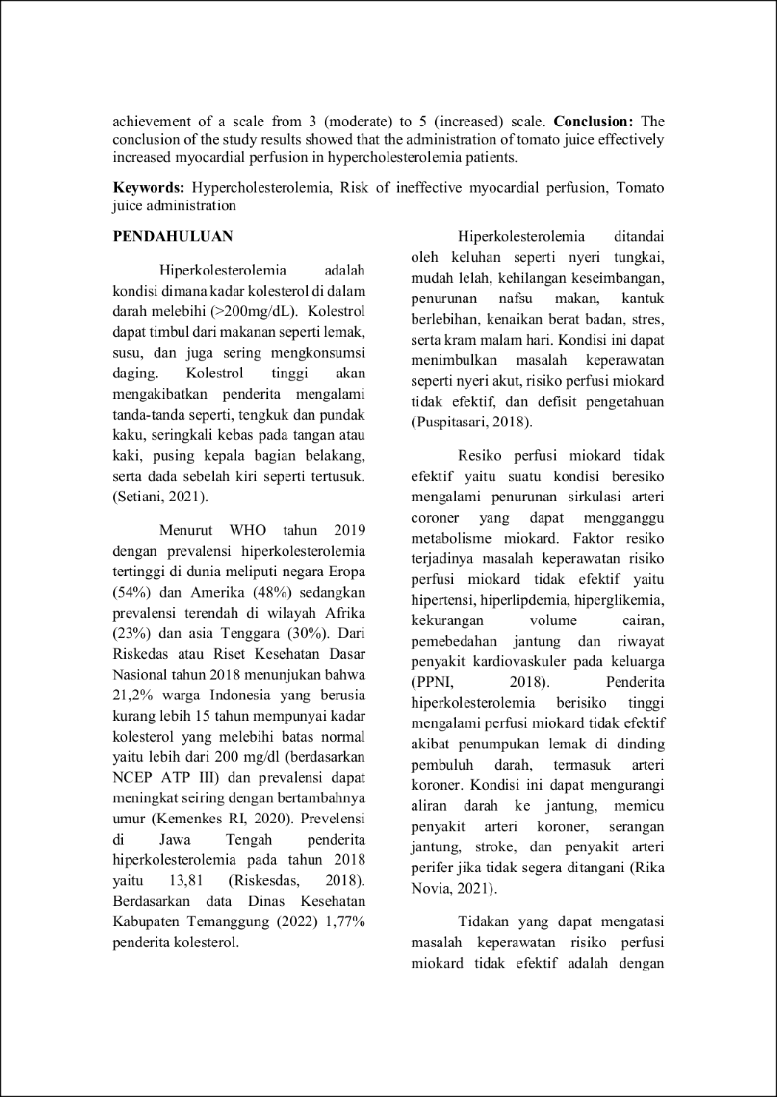
7
8
16
6
8
6
8
13

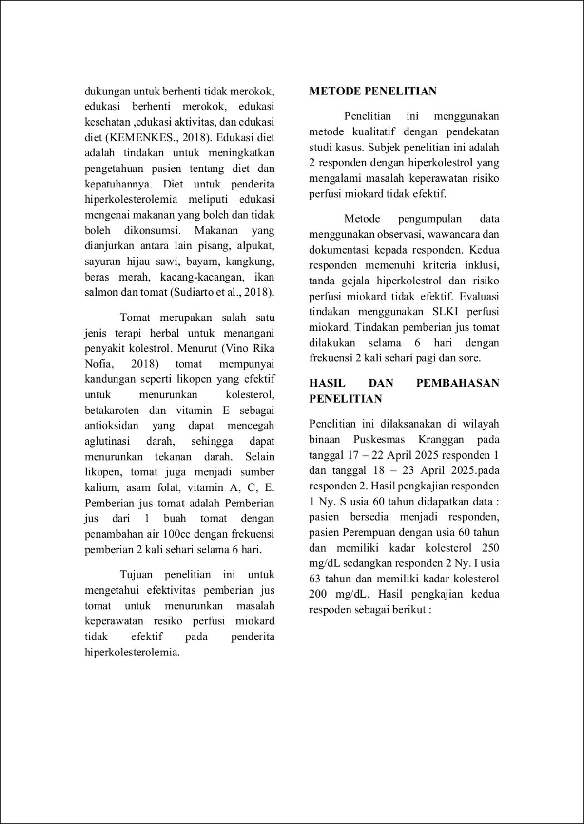
5
10
10
1
4
18
13
18
1

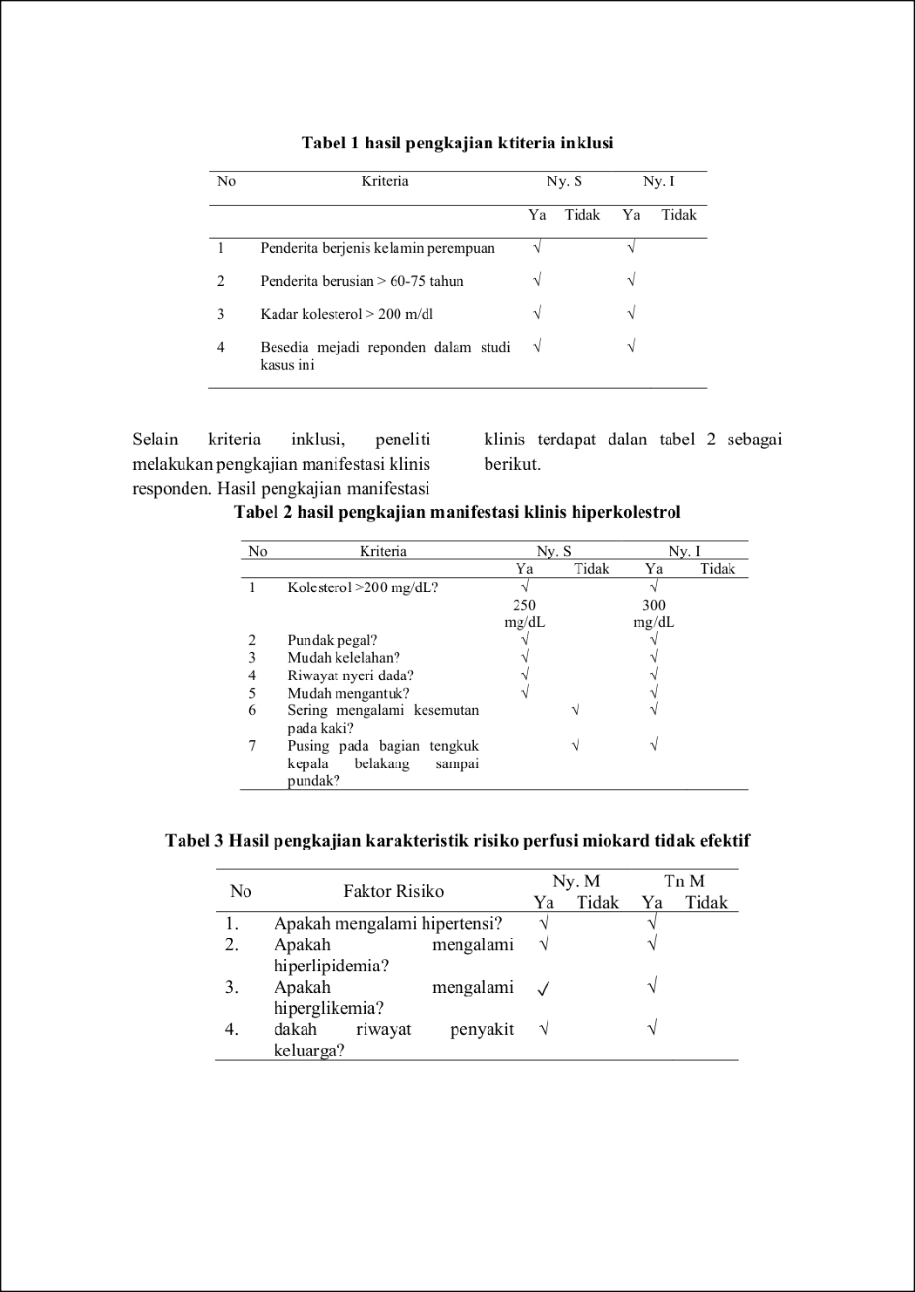
15

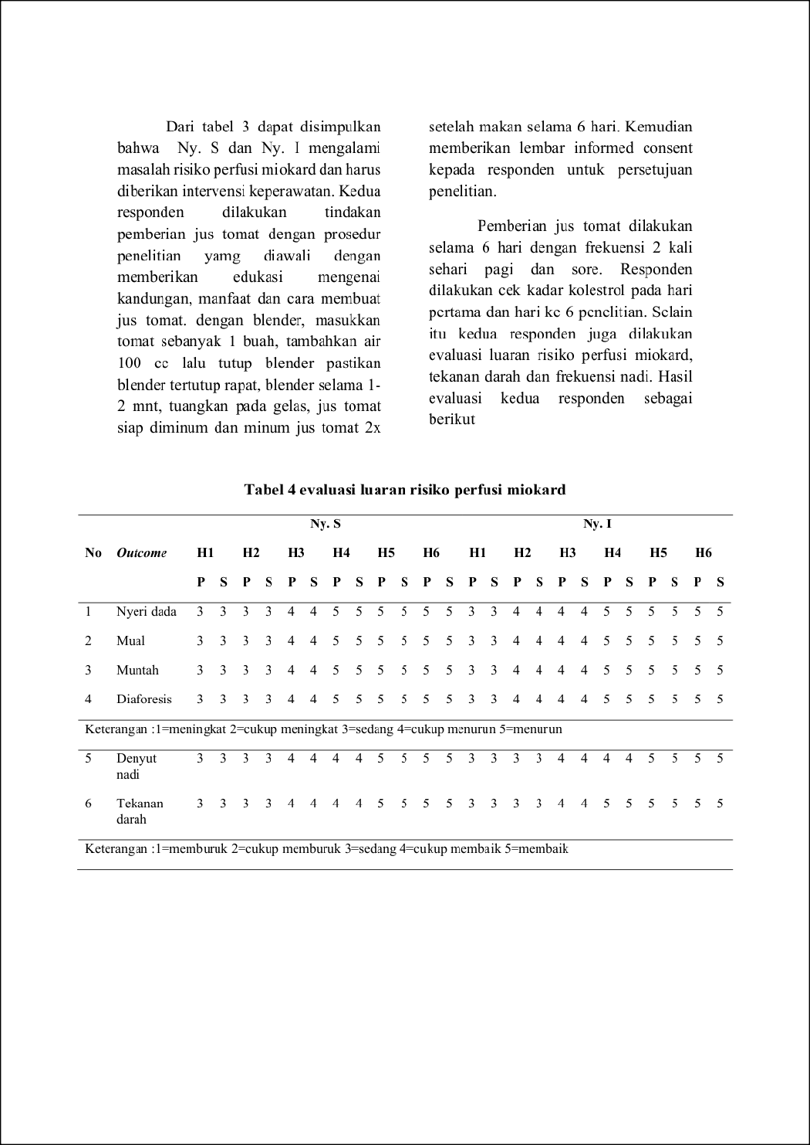
4
5
19

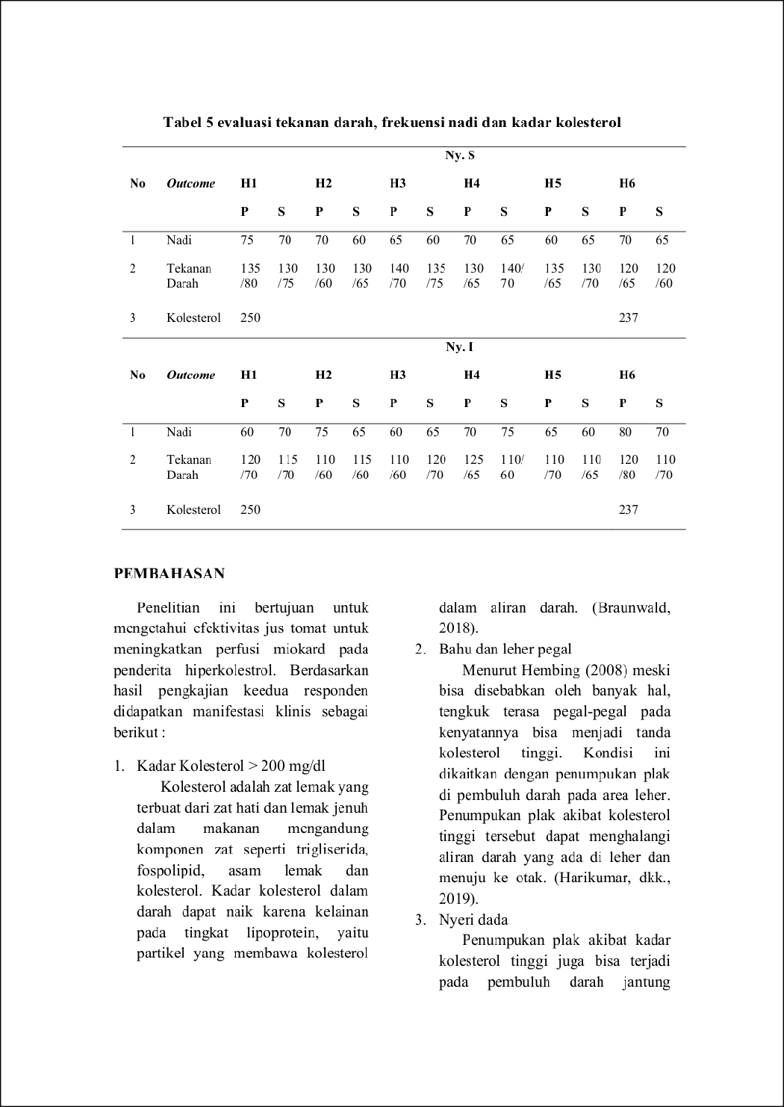
12
12
10
2
7
7

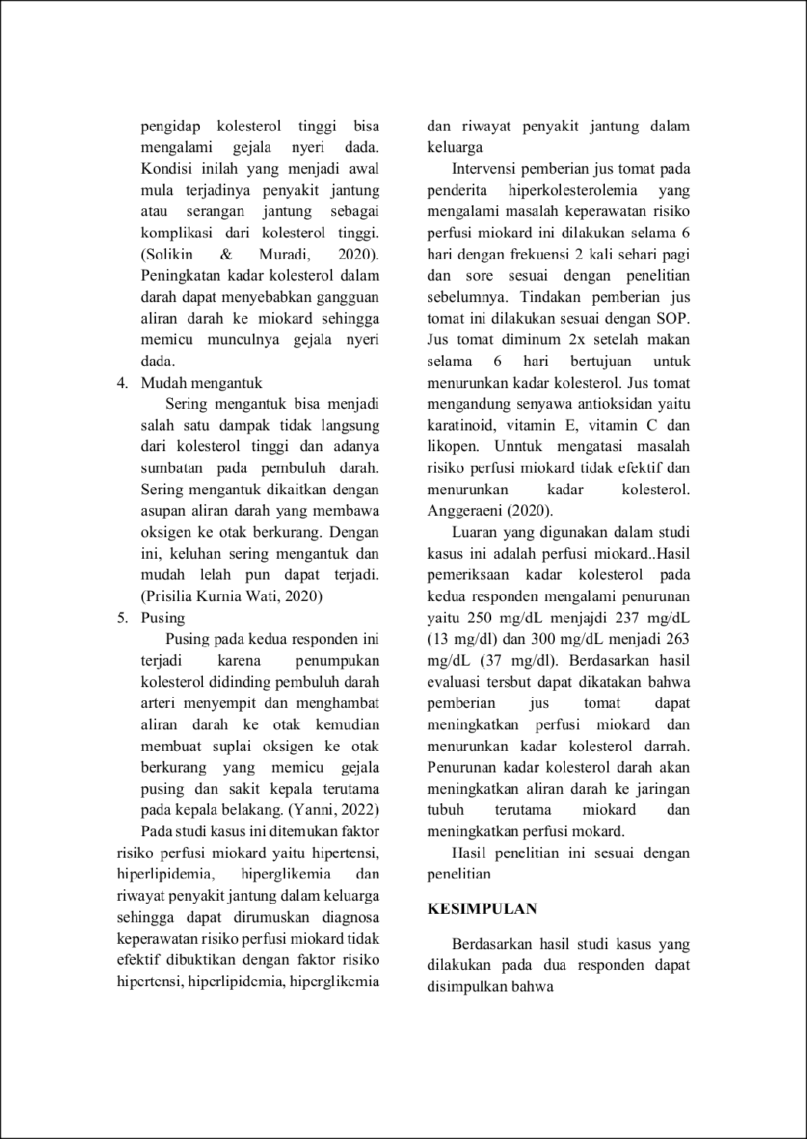
4
3
15
4

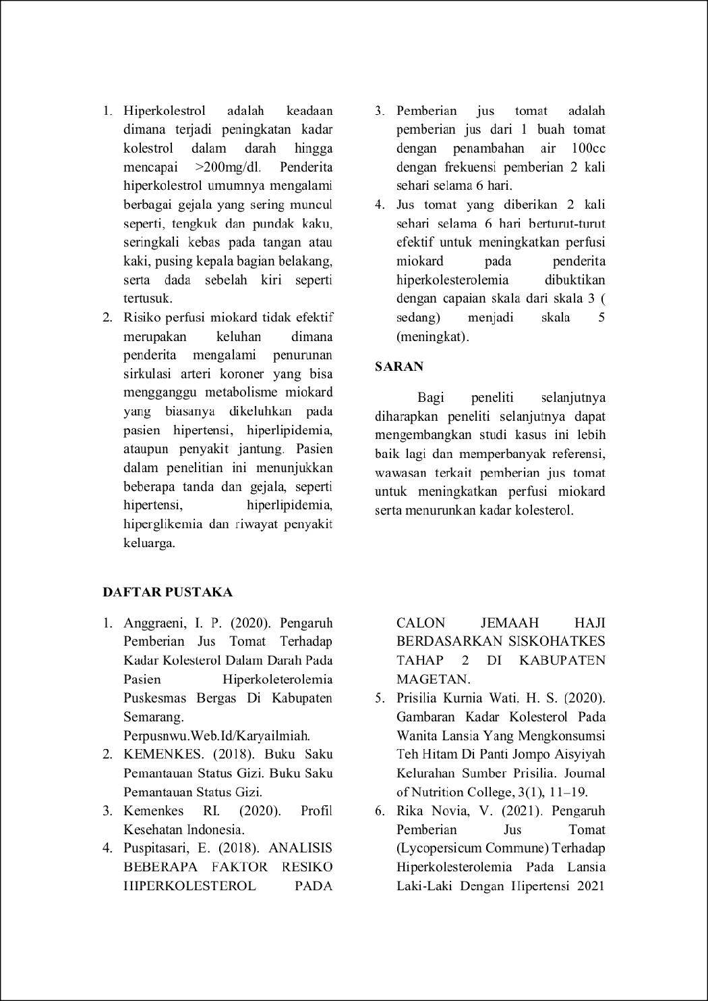
17
5
16

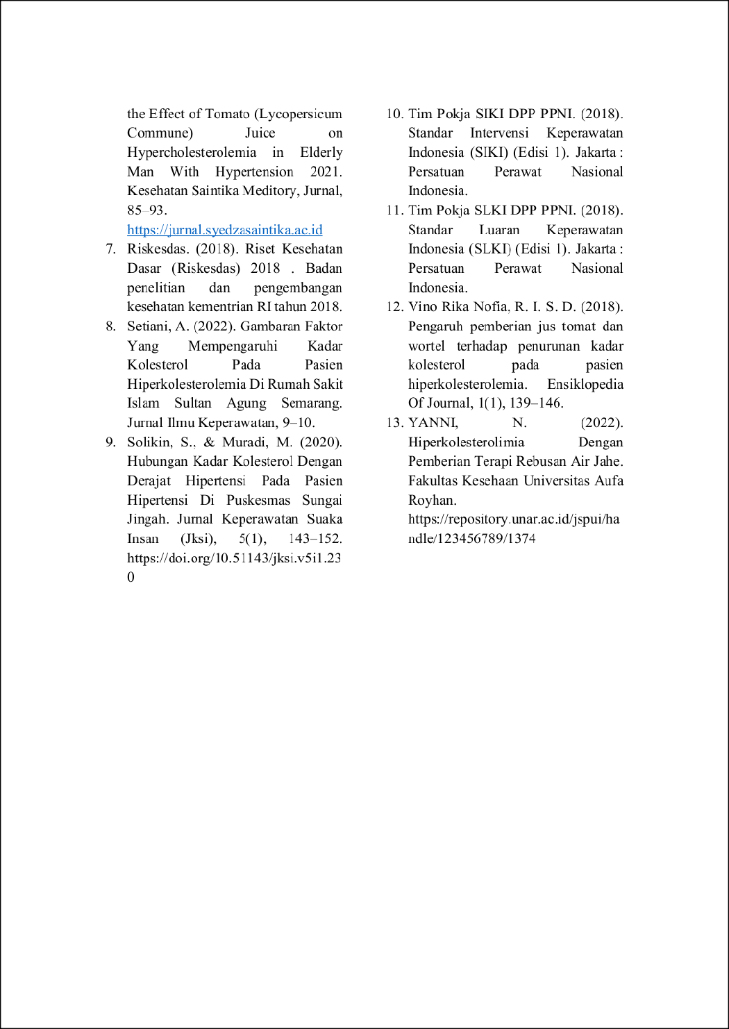

jurnalirmaa
ORIGINALITYREPORT
17

%
SIMILARITYINDEX

23%
INTERNETSOURCES

8%
PUBLICATIONS

4%
STUDENTPAPERS

PRIMARYSOURCES

1

2

3

4

5

6

7

8

9

10
123dok.com
InternetSource %
2

health.kompas.com
2
InternetSource %

aktual.kontan.co.id
2
InternetSource %

AniLestari,LenaAtoy,TaamuTaamu. "PenerapanPerawatanPayudarapadaPasien PostNatalCare(PNC)terhadapKeberhasilan Menyusui",HealthInformation:Jurnal Penelitian, 2019
2%
Publication
dspace.umkt.ac.id
2
InternetSource %

repo.stikesbethesda.ac.id
2
InternetSource %

repo.stikesicme-jbg.ac.id
2
InternetSource %

prin.or.id
1
InternetSource %

lipsus.kompas.com
1
InternetSource %

digilib.uin-suka.ac.id
1
InternetSource %

jurnal.poltekkespalembang.ac.id

11

12

13

14

15

16

17

18

19
InternetSource
%
1
SubmittedtoUniversitasAndalas
1
StudentPaper %

repository.unusa.ac.id
1
InternetSource %

repository.poltekkesbengkulu.ac.id
1
InternetSource %

repository.stikeshangtuah-sby.ac.id
1
InternetSource %

repository.umj.ac.id
1
InternetSource %

qdoc.tips
1
InternetSource %

DiyahCandraAnita,FinaDyahPramesti."Jus tomatmampumenurunkankolesteroltetapi tidakberefekpadatekanandarah",JHeS
1%
(JournalofHealthStudies),2020
Publication
www.coursehero.com
1
InternetSource %

Excludequotes On Excludebibliography On
Excludematches <15words

